In-Person Therapy Interest Form
Name of client: ________________________________________________
DOB of client: _____/_____/__________
Is this client a current client? If so, which therapist do they currently see?
YES NO ________________________________________________
Which therapists is the client willing to see for in-person sessions?
__________________________________________________________________________________________________________________________________________________________________________________________________________________________________________
What days & times would the client be able to do in person sessions?
________________________________________________________________________________________________________________________________________________________________________________________________________________________________________________________________________________________________________________________
How often would in person sessions be desired?
Weekly Every 2 weeks Once a month Other: ______________________
What cities would the client be able to get to for sessions?
______________________________________________________________________________________________________________________________________________________________________________________________________________________________________________________________________________________________________________________________________________________________________________________________________
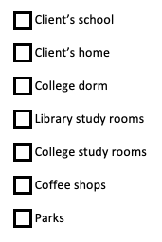
Which in person options are of interest:

If you or your provider are exposed to coronavirus or any other infection and/or contagious disease, would you rather switch to telehealth until the risk has passed or simply reschedule/temporarily pause sessions?

Switch to telehealth Reschedule/temporarily pause

If the client is a child, do they wish to participate in play therapy? YES NO
If you have insurance, if your insurance does not cover that location, are you willing to switch to self-pay or would you rather return to tele-health or simply seek services elsewhere?

Self-Pay Return to tele-health Seek services elsewhere N/A

Is there anything else you would like to let us know?
______________________________________________________________________________________________________________________________________________________________________________________________________________________________________________________________________________________________________________________________________________________________________________________________________

